IELTS TEST 2

1. Listening
2. Training
3. Discount
4. Taxi
5. Service
6. English
7. Wivenhoe
8. Equipment
9. 9.75
10. Deliveries
11. Sunday
12. E
13. B
14. D – B Correct
15. C
16. G
17. C
18. D
19. B
20. H
21. A
22. A - C Correct
23. C - A Correct
24. A
25. B
26. B
27. D - A Correct
28. Live stock effect - D
29. Severe drought, crops failed, more people dying in anyother country - B - A Correct
30. Mortality rose up alot, under age of 35 - C
31. Geore washington was snowbound, ice floating down missisipi - F
32. Convenient
33. Garments - Suits Correct
34. Tailor
35. Profession
36. Visible
37. Strings
38. Knees - Waits Correct

38. Perfume

39. Image

40. Handbag

33/40

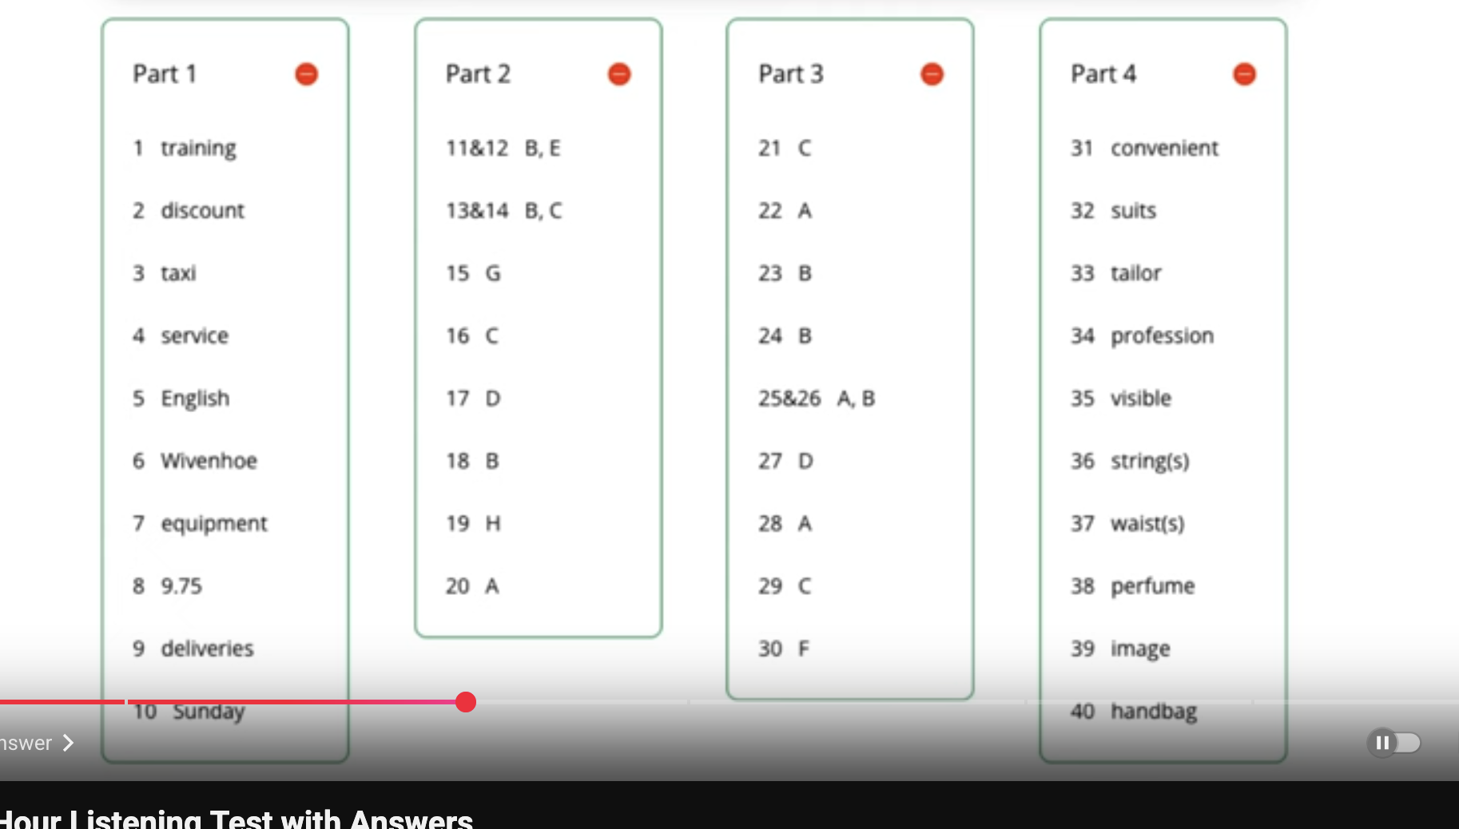

Questions 1 - 8:

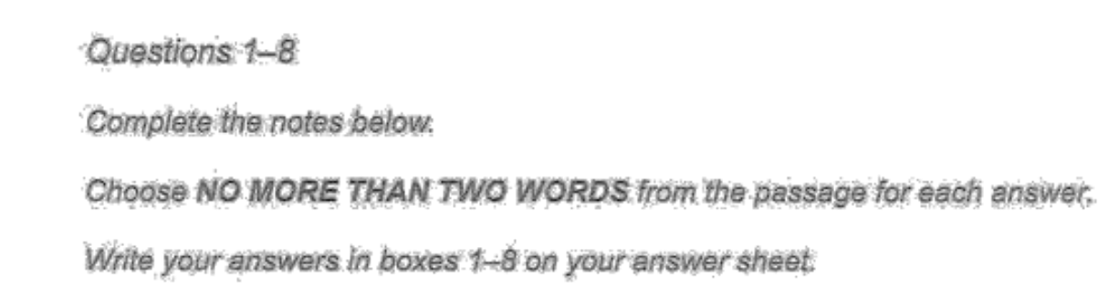

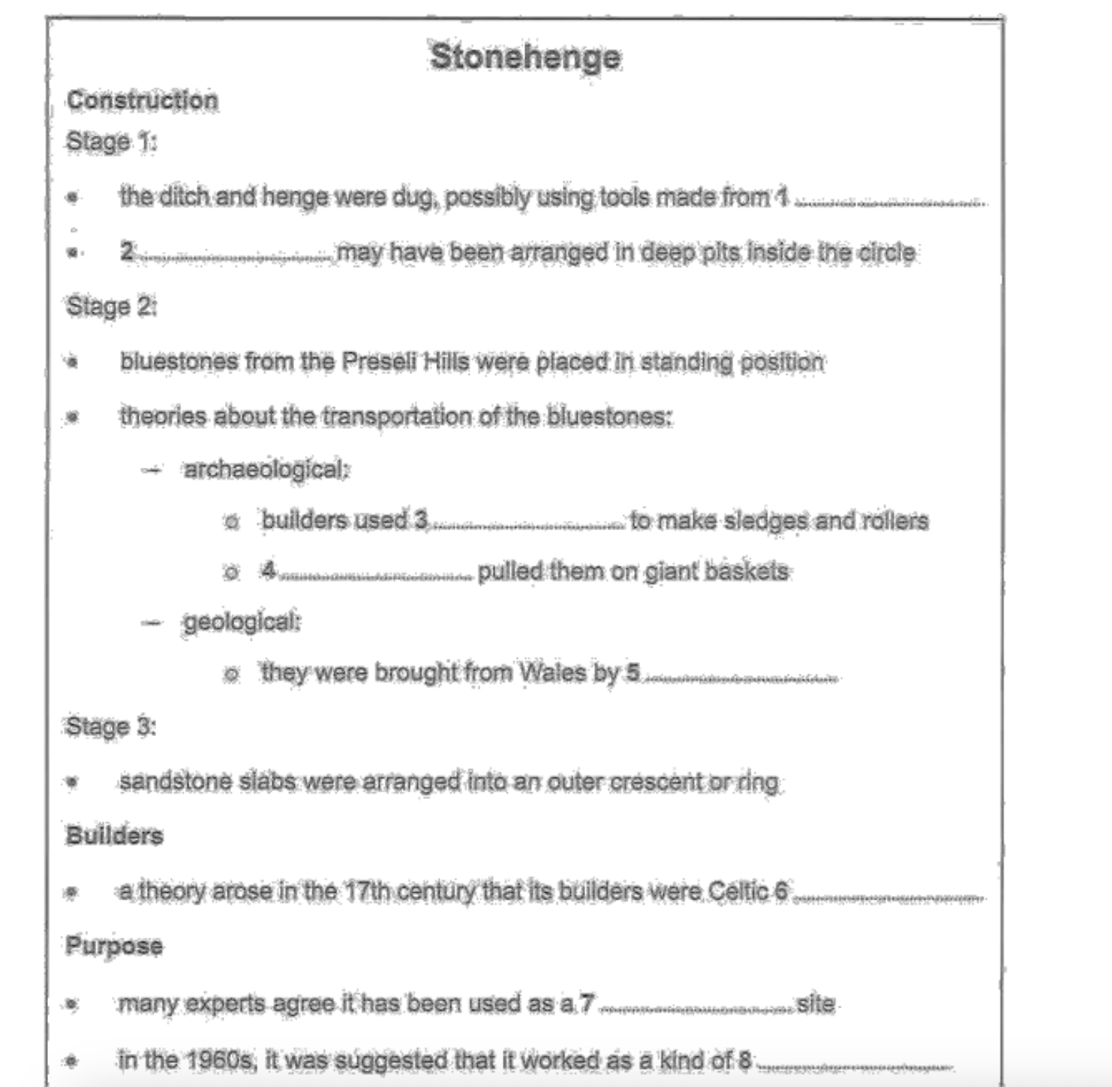

1. Deer Antlers
2. Bluestones – X, Timber Posts
3. Tree Trunks
4. Hauling – X, Oxen
5. Oxen – X, Glaciers
6. Society – X, Druids
7. Burial Ground
8. Calendar

4/8

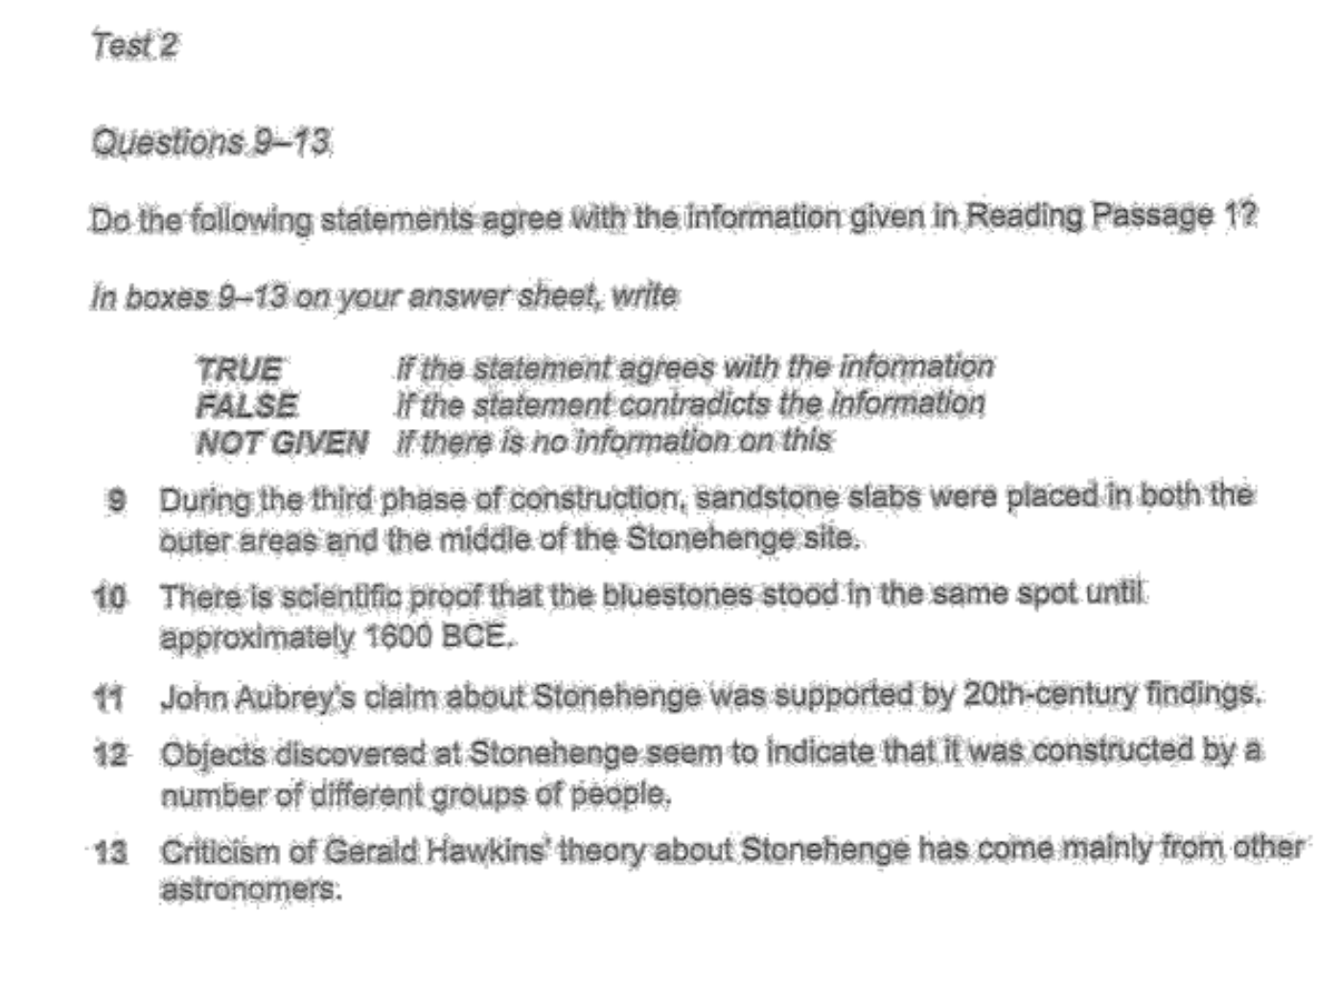

9. True

10. False

11. False

12. True

13. False – X, NG

4/5

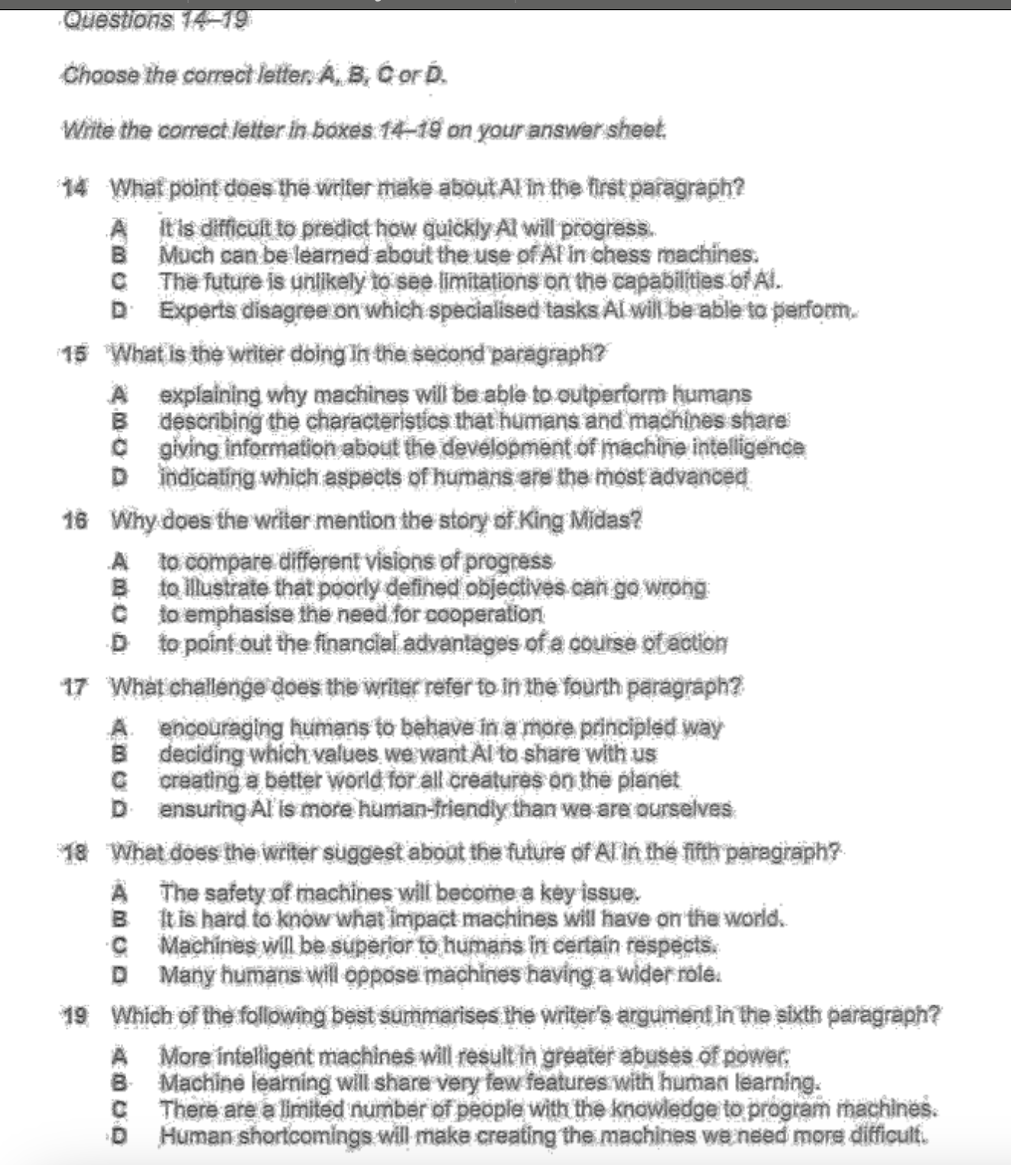

14. X-D, X-B, C- Correct

15. X-C, X-D, A-Correct

16. X-A,X-C,X-D, B - Correct

17. X-B,D-Correct

18. A

19. D

2/5

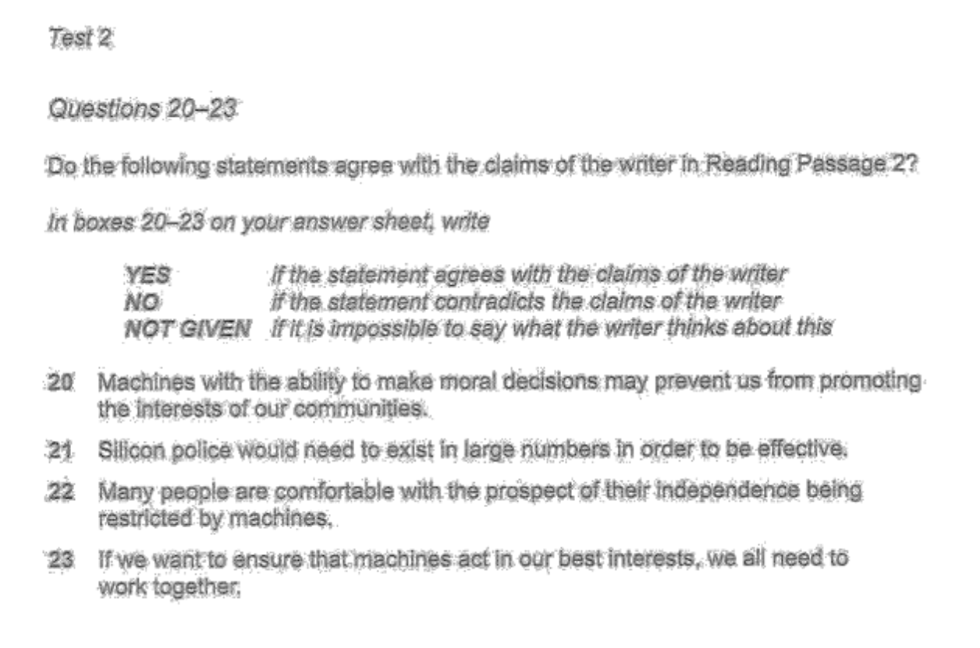

20. Yes

21. Not Given

22. No

23. Yes

4/4

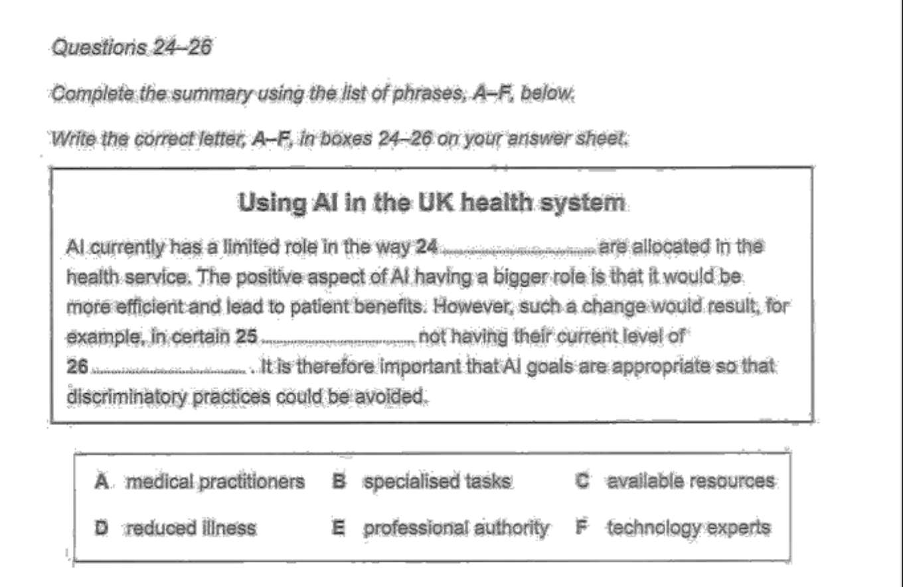

24. C

25. A

26. E

3/3

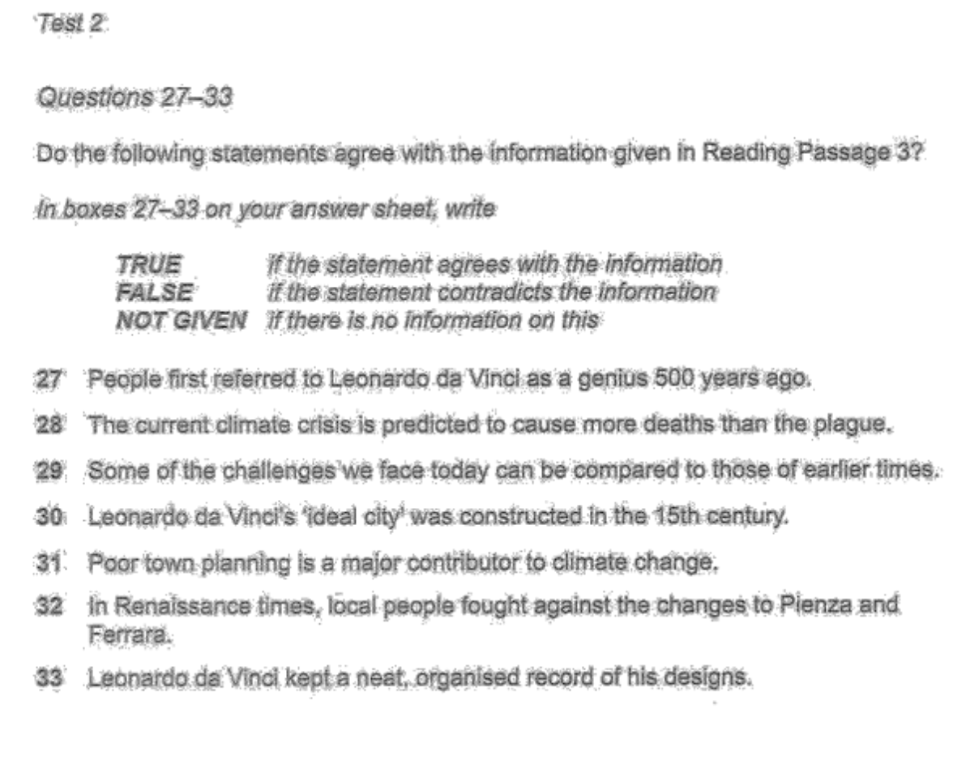

27. True – X, NG

28. Not given

29. True

30. False

31. NG – X, True

32. False

33. False

5/7

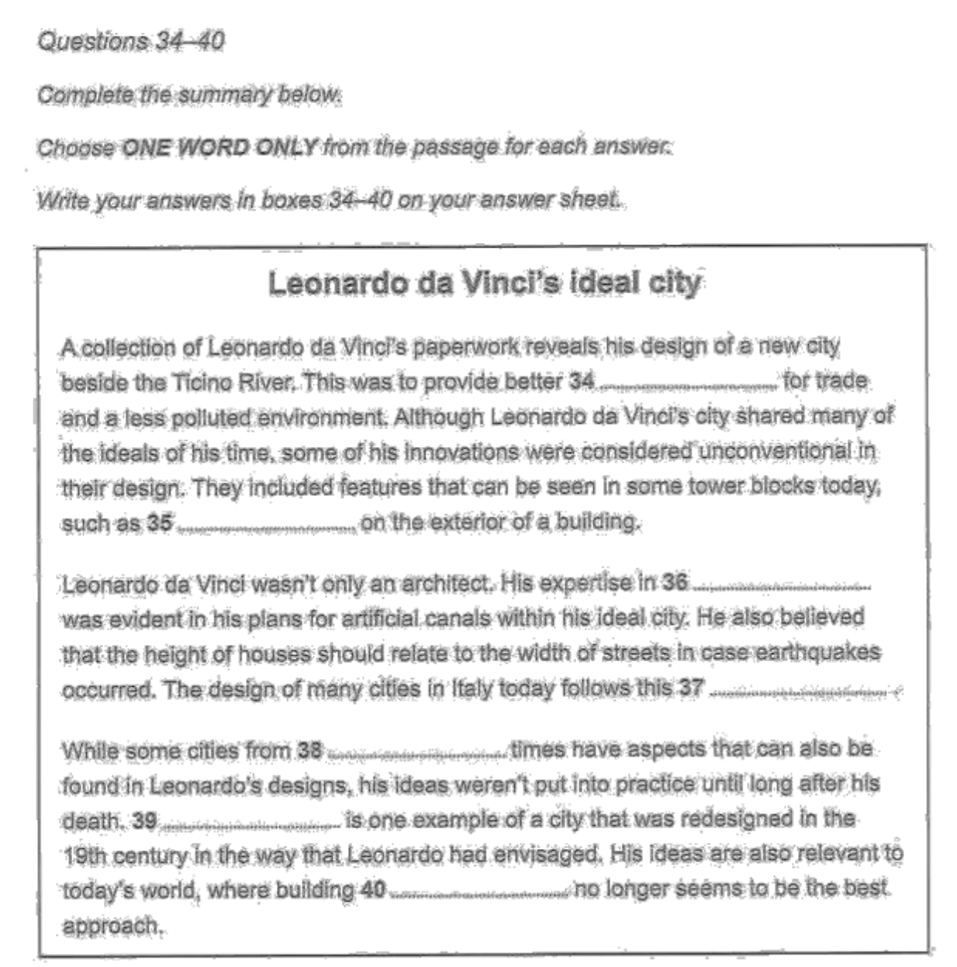

34. Transport 35 – X, Stair Cases. 36. Engineering 37. Rule 38. Roman 39. Paris 40.Flat – X, cutwards

4/6

26/40 – NOT GOOD!

Writing:



Features:

Number of households Households by annual income - 2007, 2011, 2015

The 100k$+ remained stagnant and even dipped between 2007 and 2011 and finally rose in 2015. With the emerging market of a large number of billionaires over the years this may be one of the contributing factors why in 2015 the market rose alot from this segment

Between 75k-99k$ & 50k$ to 75k$ have remained stagnant throughout the years

< 25k$ has rose over the years. Alot of people are trying to purchase land so a small landowners can rent these for less than 25k$.

Synonyms:

This bar graph shows number of households on Y-axis with their annual income in US across the years in 2007, 2011, and 2015.

Overall it can be observed that the 100k$+ and less than 25k$ annual income categorie lets name them as ‘A’ category, are rising in number of households whilst on the other hand 25k$-50k$, 75-99k$ and 50-75k$ categories lets assume them as ‘B’, have remained stagnant through the years.

On one hand the category ‘A’ has been seen significant growth over the years in terms of number of households growth. The 100k$+ may have seen significant growth because of the emerging market of a large number of billionaires mostly from the techsector contributing to the factors till 2015. These billionaires purchase these lands and then rent them on high prices which may range 100k$+ to the emerging millionaires for startup space, co-working spaces etc. It can be assumed major contribution to this 100k$+ mark my come from the San Francisco as it is famous for its high rental costs. The less than 25K$ mark also has seen significant uprise over the years with a small dip coming in the 2015 which infers middle class people buying small lands for households and renting them for lower middle class in the country. All in all the 100k$+ mark for annual income also has the highest number of households since 2007, whilst the less than 25k$ has remained as the 3rd highest in the chart.

On the other hand, the category ‘B’ has remained stagnant in most of the 3 years except for the 25k$-50k$ mark, which has seen small improvements. The inference can be based on the divide of classes over the years in America, where the number of millionaires has been rising, whilst simultaneously the middle class, because of inflation, has dropped to a lower middle class status. Thus, either people can afford below 25k$ annual rent or the rich can avail the 100k luxurious offers.

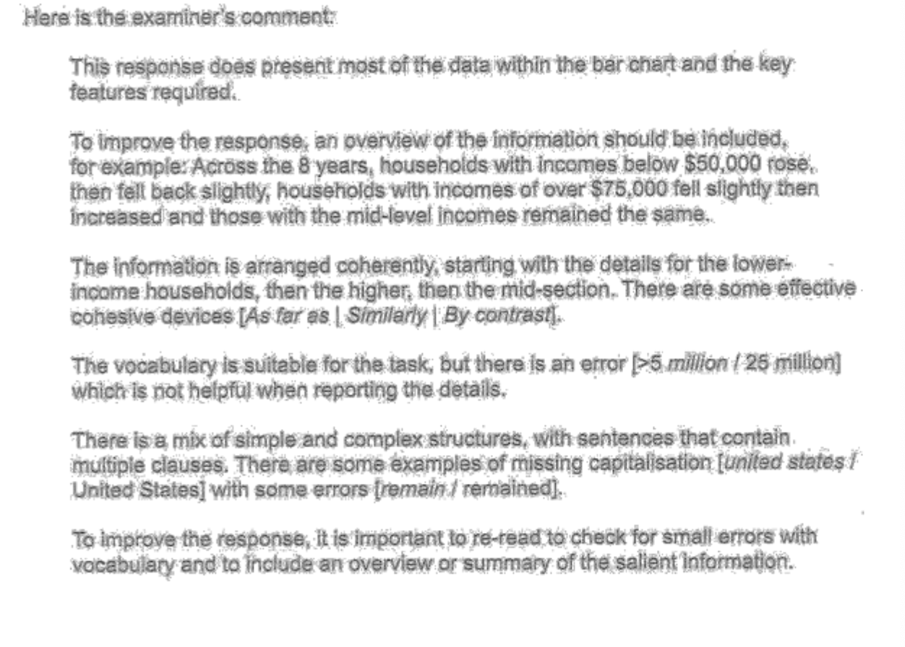

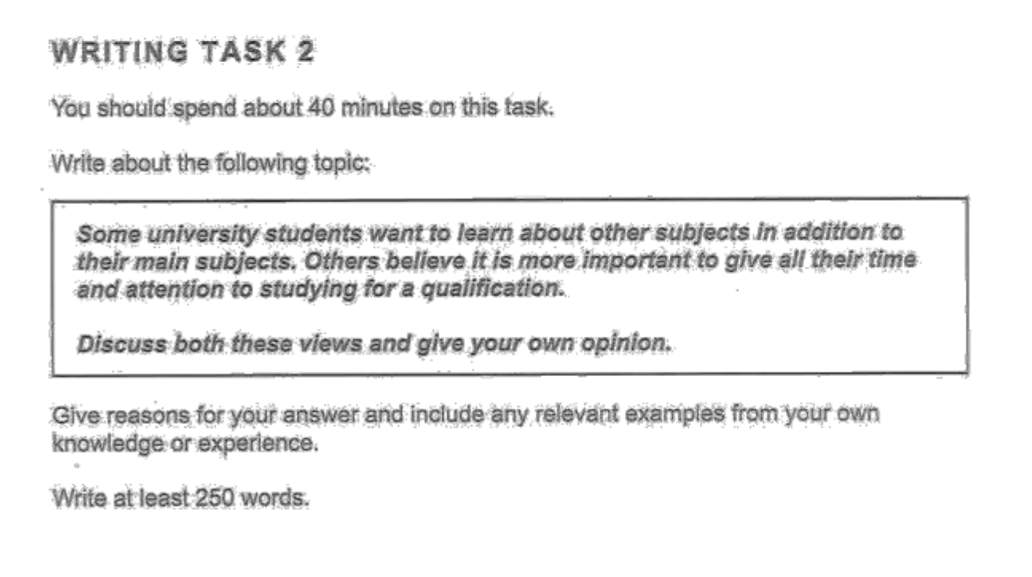

Ideas:

1. Generalist Approach: Studying subjects outside the curriculum allows for creativity and intermix of different fields to create unique problem solving ideas that have solved large scale issues in numerous ways such as Combining Legal Law With AI has allowed lawyers to generate draft, and review legal documents in 58% less amount of time than before. Qanooni Example where i worked at.
2. Specialist Approach: Maintaining your focus on only the qualification related curriculum allows to deepeen knowledge and tends more towards specialization. Me specializing in backend development allowed me to develop large scale projects of software engineering in different domains such as AI, Blockchain and Cloud.

Synonyms:

Students: university alumni

Some:

It’s argued that some students want to ingest knowledge that goes beyond the curriculum and in contrast other students want to focus on the main courses being taught. The essay will discuss both the view points. The following paragraphs would discuss the generalist and specializatist approaches.

On one hand, we have the generalist approach implies the alumni who want to include knowledge that is beyond the curriculum taught. They want the freedom for creativity and intermixing of different fields to create unique problem-solving ideas that have solved large-scale issues. For example, I worked as an AI engineer at Qanooni AI for legal law automation. I was granted the freedom to explore the legal field, combined with AI to generate drafts, and review legal documents in 58% less amount of time than before. Qanooni Example, where i worked at.

On the other hand, there is a specialist approach that allows the individuals to maintain focus on what is being taught related to the curriculum. This allows them to put time and deepen knowledge that is being taught, and lean more toward specialization. For example, I specialized in backend engineering, which allowed me to develop large-scale projects of software engineering projects in different domains such as AI, Blockchain, and Cloud.

In conclusion both specialization and generalist people are required in every field which results in a cohesive system of team work and diversity of thoughts. This is the reason why Universities should allow students to have the freedom to adopt any of the views but my recommendation is to be a jack of all trades but master of one.

IN THE ABOVE the examples the focus should have been more on the university and alumni shouldnot have been used as it means former students

Pros and cons of both had not been addressed which shouldve been a part of the essay structure

